INT333 - DEVOPS ADVANCE CONFIGURATION MANAGEMENT
Commands

sudo apt update && sudo apt upgrade -y
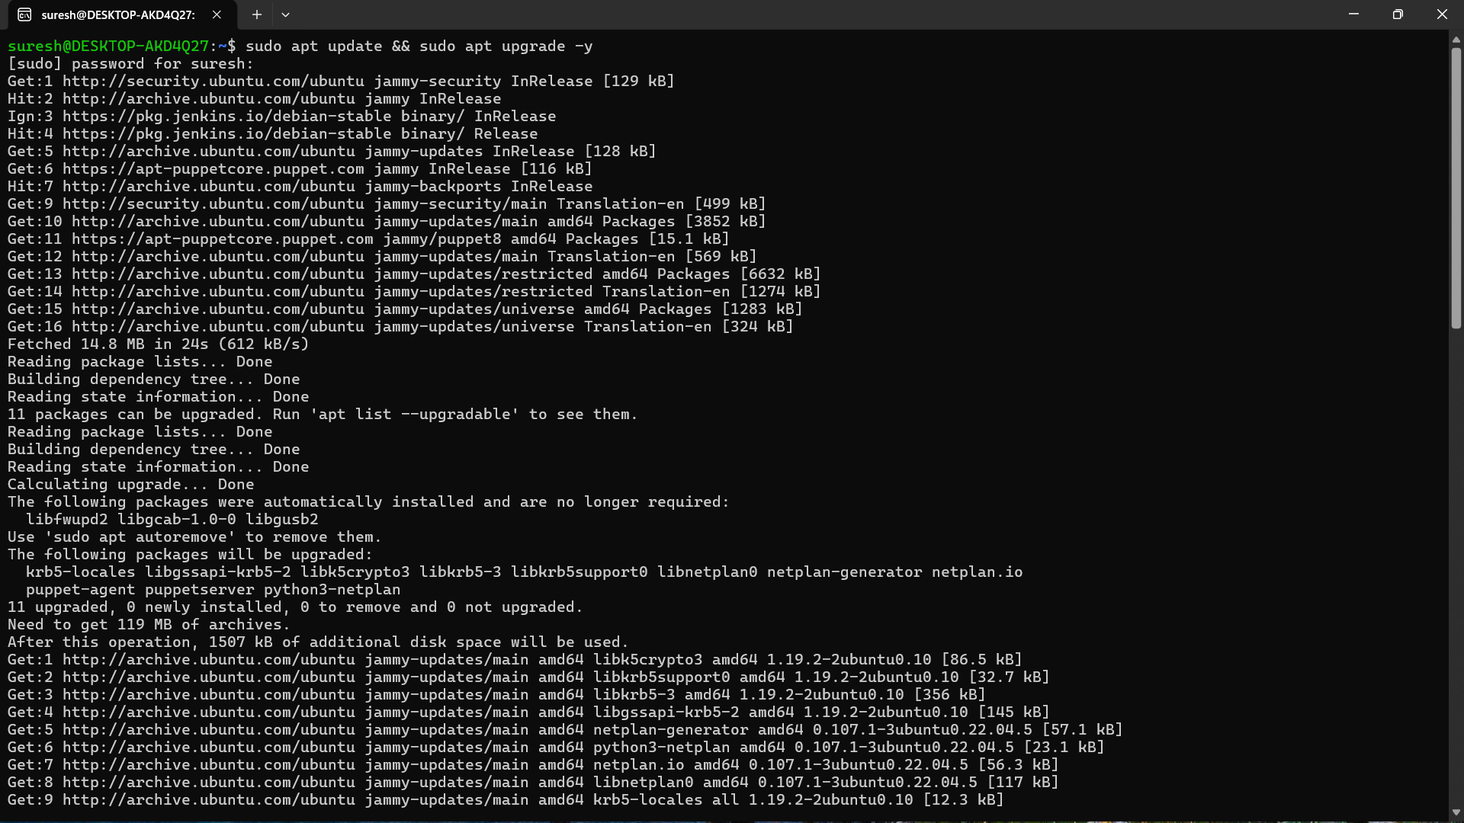
sudo hostnamectl set-hostname puppetserver
hostname
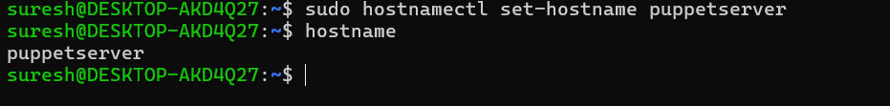
ip addr

sudo nano /etc/hosts
127.0.0.1 localhost
127.0.1.1 puppetserver
192.168.56.10 puppetserver

ping -c 3 puppetserver

wget https:// apt-puppetcore.puppet.com/public /puppet8-release-jammy.deb

sudo dpkg -i puppet8-release-jammy.deb

sudo nano /etc/apt/auth.conf.d/apt-puppetcore-puppet.conf

machine apt-puppetcore.puppet.com
login forge-key
password YOUR_API_KEY

sudo apt update

sudo apt install puppetserver -y

sudo /opt/puppetlabs/bin/puppetserver -v
sudo systemctl start puppetserver
sudo systemctl enable puppetserver
sudo systemctl status puppetserver
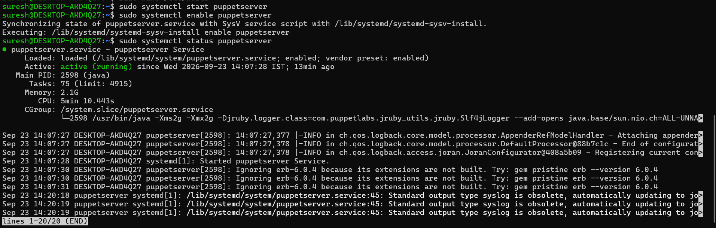

Configure Puppet Server(Edit /etc/puppetlabs/puppet/puppet.conf)
[main]
certname = puppetmaster.example.com
server = puppetmaster.example.com
environment = production
runinterval = 1h

sudo /opt/puppetlabs/bin/puppet config print certname --section server

sudo /opt/puppetlabs/bin/puppet config print server --section main

sudo /opt/puppetlabs/bin/puppet config set server puppetserver --section server

sudo /opt/puppetlabs/bin/puppetserver ca list

sudo /opt/puppetlabs/bin/puppetserver ca sign --certname wahla

sudo openssl x509 -in /etc/puppetlabs/puppet/ssl/certs/puppetserver.pem -noout -subject -issuer -serial -dates

: For windows Agent :
You are currently at:PS C:\Windows\system32>
Step 1 — Check whether Puppet is still installed

Run only this command:

Test-Path "C:\Program Files\Puppet Labs\Puppet\bin\puppet.bat"
If it returns:
True then OK proceed with next step
Then run:

& "C:\Program Files\Puppet Labs\Puppet\bin\puppet.bat" --version

You should get:

8.10.0

Then add Puppet to the current PowerShell PATH:

$env:Path += ";C:\Program Files\Puppet Labs\Puppet\bin"

Now:

puppet --version

Then
Step 1 — Windows Agent

Open Administrator PowerShell and run:

cd "C:\Program Files\Puppet Labs\Puppet\bin"

Then configure the Puppet Server name:

.\puppet.bat config set server puppet --section main

Verify:

.\puppet.bat config print server

It should show:

puppet
Step 2 — Windows Agent: verify name resolution

Run:

ping puppet

It should resolve to:

172.31.5.181

Then test TCP 8140:

Test-NetConnection puppet -Port 8140

You want:

TcpTestSucceeded : True
Step 3 — Windows Agent: create SSL request

Run:

.\puppet.bat ssl bootstrap

Stop here after this command.

If it says the certificate request is waiting for signing, that's correct.

Step 4 — Ubuntu Puppet Master

Go to your Ubuntu server and run:

sudo /opt/puppetlabs/bin/puppetserver ca list --all

Step 5 — Back to Windows Agent

Run:

.\puppet.bat ssl bootstrap

Then finally:

.\puppet.bat agent --test

